How to Write a “How to” Blog Post

Whether it’s “how to make chicken parm” or “how to start a business,” people are searching “how to” do things on Google all the time. And you can help those people out with a “how to” blog post.

“How to” blog posts provide your readers with a step-by-step guide to doing, well, anything. These blogs are also an amazing opportunity for your company to position itself as customer-focused and selfless, as you’re laying out a tactical approach to fixing a problem or addressing a need without asking for anything in return. This helps to make your brand synonymous with trust.

Writing these posts can also help your blog rank for Google’s **featured snippet** – the box that appears in Google search results with a few dozen words answering the question. You can see an example of this below.

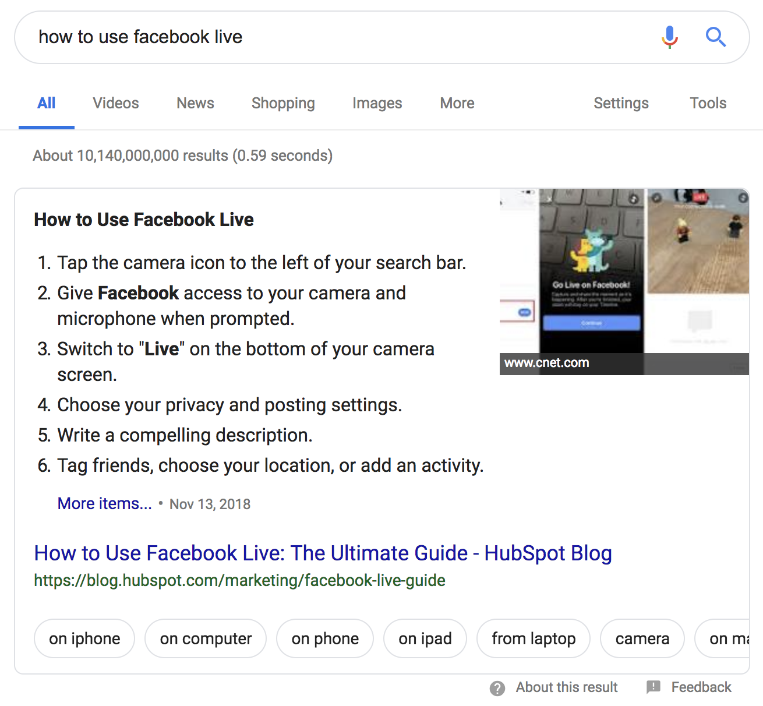

“How to” blog posts are best for the following blog posts:

* Math and equation explanations [i.e. “[How to Calculate Net Promoter Score](https://blog.hubspot.com/service/how-to-calculate-nps)”].
* Providing a way of thinking about or approaching an obscure task [i.e. “[How to Set & Achieve Marketing Objectives](https://blog.hubspot.com/marketing/marketing-objectives)”].
* Outlining step-by-step instructions to an easily addressable task [i.e. “[How to Block Websites on Chrome Desktop and Mobile](https://blog.hubspot.com/marketing/block-websites-on-chrome)”].

Outline: [Blog Post Title]

**Keyword:** [Enter Targeted Keyword]

**Keyword MSV:** [Enter Targeted Keyword’s Monthly Search Volume]

**Author:** [Enter Author Name]

**Due Date:** [Enter Due Date]

**Publish Date:** [Enter Desired Publish Date]

**Buyer Persona:** [Enter Targeted Reader and/or Buyer Persona]

[Blog Post Title]

*Make sure the title starts with “How to…” and runs for 60 characters or less.*

## Introduction

*Lead into the post with a short 100-200 word introduction. Be sure to highlight:*

* *The reason why what you’re talking about is important.*
* *Who, what industry, or what sector of the industry this applies to.*
* *What you’ll be covering [i.e. “in this post, we’ll explain why (term) is important, explain how to (term), and provide 8 suggestions if you’re new to (term)”].*

## What is [Term], and Why Does it Matter?

*Some readers may have no idea what it is you’re explaining how to do. Obviously, if what you’re writing about is well-known, you can skip the definition.*

*After defining the term, explain why it’s important for the reader to understand the idea and/or know how to do what you’re writing about.*

## How to [Task]

*This section should make up the bulk of the writing in your blog post. It’s enormously important for each step to* ***have its own section header*** *for optimal organization, clarity for the reader, and search engine optimization. Additionally, breaking instructions up by sections also lets you include visual aids for each step as needed in the form of a GIF, image, or video.*

*It’s important to remember to be* ***clear, concise, and accurate*** *in the steps you provide your readers. Any extra “fluff” to the article may confuse them, resulting in some readers not achieving the results they intended.*

*If what you’re explaining how to do is solve an equation (i.e. “How to Calculate Break Even”), provide a step-by-step explanation and example of how to calculate the rate, point, or number you’re explaining how to reach. Show all of your work so the reader can follow along easily.*

## # Tips and Reminders for [Term] (Optional)

*If you’re breaking down a difficult concept or task, some readers may still feel overwhelmed and unsure of their ability to tackle it. Break down a few suggestions on how to best approach the concept, and/or a few reminders about it. This is not a list post, so keep this short list to three to five pieces of advice.*

*If you feel the step-by-step approach is sufficient, you can choose not to include this section.*

## Closing

*Wrap up your amazing new blog post with a great closing. Remind your readers of the key takeaway you want them to walk away with and consider pointing them to other resources you have on your website.*

## Call-to-Action

*Last but not least, place a call-to-action at the bottom of your blog post. This should be to a lead-generating piece of content or to a sales-focused landing page for a demo or consultation. For example, if your product or service helps your readers do what it is they searched “how to” do, or if you have a template in your content resource library that does what they searched “how to” do, that would be a perfect CTA for this post.*

Checklist Before Publishing

* Did you provide clear, actionable steps to accomplishing the task your reader needed help with?
* Did you provide relevant and accurate facts and stats to prove your understanding of the concept?
* Did you emphasize the importance of understanding this concept if it is not already well-known?
* Did you properly cite and backlink your sources?
* Did you spell check and proofread?
* Are there **at least** 1-2 images?
* Is the post 800-1,000 words at minimum?